

Course Title: Database Systems Lab
Course Code: CSE – 212
Project Name: Restaurant Management System

Submitted By- Submitted To-
Name:Rafi Ahammed Rajon Alif Ruslan
Tasnim E Mubasshira Lecturer
Foujiha Jahan Prome University Of Asia
Pacific

Registration:23201150,
23201151,
23201152

1. Project Description
The Cinema Booking System is designed to manage movies, theaters, customers, showtimes, bookings, tickets, and payments efficiently. The system allows tracking of movie screenings, customer memberships, ticket sales, and payments, providing a complete overview of cinema operations. The project demonstrates relational database concepts using SQL, including table creation, data insertion, querying, and advanced operations like aggregate functions, joins, and subqueries.

2. Entities and Their Descriptions

Entity | Description
Movie | Stores information about movies including ID, title, category, duration, release date, and rating.
Customer | Stores customer information like ID, name, email, phone, age, gender, and membership type.
Ticket | Represents tickets with seat number, price, and status.
Theater | Represents theaters with ID, name, location, and total number of seats.
Showtime | Represents showtimes of movies in specific theaters including date and time.
Booking | Tracks which customer booked which movie and showtime along with booking date.
Payment | Stores payment details including amount, payment method, date, and associated theater.

3. Table of Work
Table Name | Purpose | Key Columns
Movie | Manage movie details | movieId (PK), title, category, duration, releaseDate, rating
Customer | Manage customer details | customerId (PK), name, email, phone, age, ageGroup, gender, membership
Ticket | Manage ticket details | ticketId (PK), seatNo, price, status
Theater | Manage theater details | theaterId (PK), name, location, totalSeats
Showtime | Track movie showtimes | showId (PK), movieId (FK), theaterId (FK), showDate, showTime
Booking | Track bookings | bookingId (PK), customerId (FK), movieId (FK), showId (FK), bookingDate
Payment | Manage payments | paymentId (PK), bookingId (FK), amount, paymentDate, method, theaterId (FK)

4. Relationships Between Entities
Relationships Between Entities
- Movie ↔ Showtime: One-to-Many
  - A movie can have multiple showtimes.
  - Movie.movieId → Showtime.movieId
- Theater ↔ Showtime: One-to-Many
  - A theater can host multiple showtimes.
  - Theater.theaterId → Showtime.theaterId
- Customer ↔ Booking: One-to-Many
  - A customer can make multiple bookings.
  - Customer.customerId → Booking.customerId
- Movie ↔ Booking: One-to-Many
  - Each booking is associated with a single movie.
  - Movie.movieId → Booking.movieId
- Showtime ↔ Booking: One-to-Many
  - Each booking is associated with a single showtime.
  - Showtime.showId → Booking.showId
- Booking ↔ Payment: One-to-One
  - Each booking has a payment record.
  - Booking.bookingId → Payment.bookingId
- Theater ↔ Payment: One-to-Many
  - Payments are associated with theaters.
  - Theater.theaterId → Payment.theaterId

5.Schema Diagram
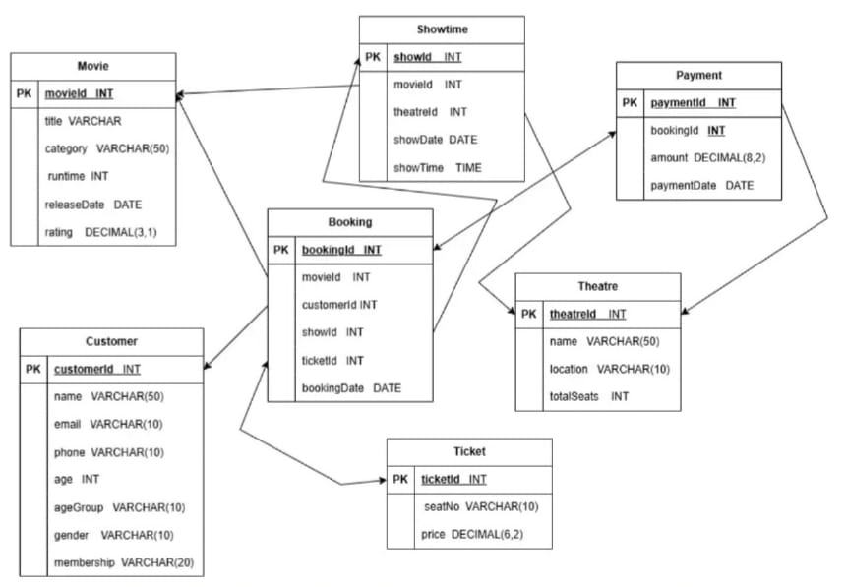
https://drive.google.com/file/d/1VH1VYfopuOD7p1uuTUb1eQv1ppYV8Jaz/view?usp=sharing

6.ER Diagram

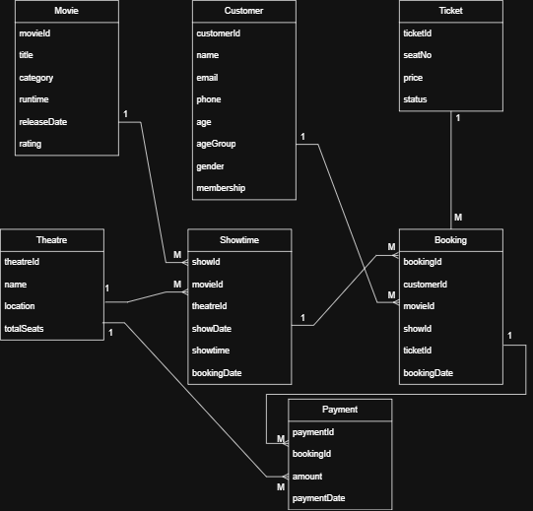
https://drive.google.com/file/d/1btSHCt0JlyYAKZy5PK9iXs6wE2S41Jbq/view?usp=sharing

7.SQL querries
Easy:
-- 1. Select all Action movies with rating above 8.0 SELECT * FROM Movie WHERE category = 'Action' AND rating > 8.0;
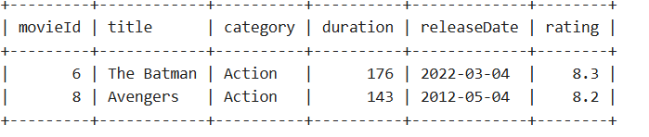

-- 2. Select Gold members or customers above 30 SELECT * FROM Customer WHERE membership = 'Gold' OR age > 30;
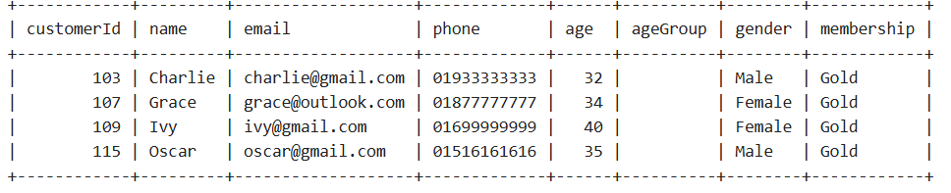

-- 3. Show all movies ordered by rating (descending)
SELECT title, category, rating FROM Movie ORDER BY rating DESC;

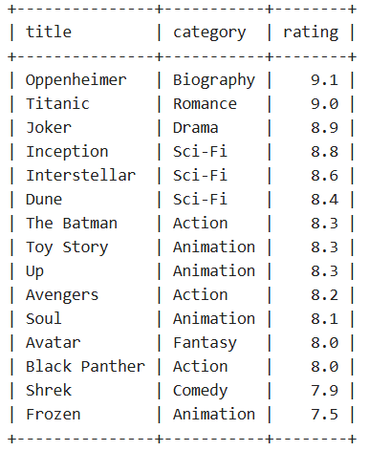

Medium:
-- 1. Count total bookings per customer
SELECT customerId, COUNT(*) AS total_bookings FROM Booking GROUP BY customerId;
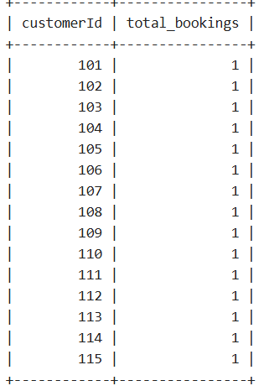

-- 3. Update membership based on age groups
UPDATE Customer SET membership = CASE WHEN age < 20 THEN 'Bronze' WHEN age BETWEEN 20 AND 30 THEN 'Silver' WHEN age BETWEEN 31 AND 40 THEN 'Gold' ELSE 'Platinum' END;
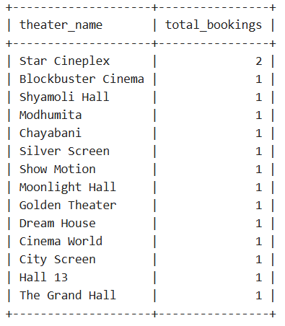

Hard:
--1Customers who booked the most expensive tickets
SELECT * FROM CustomerWHERE customerId IN ( SELECT b.customerId FROM Booking b JOIN Ticket t ON b.ticketId = t.ticketId WHERE t.price = (SELECT MAX(price) FROM Ticket));
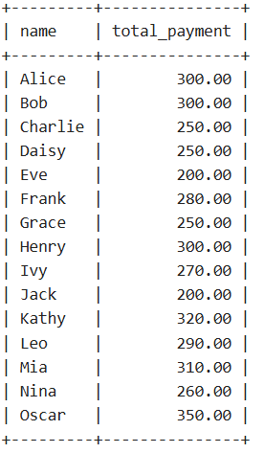
2. Movies with rating higher than average
SELECT * FROM Movie WHERE rating > (SELECT AVG(rating) FROM Movie);
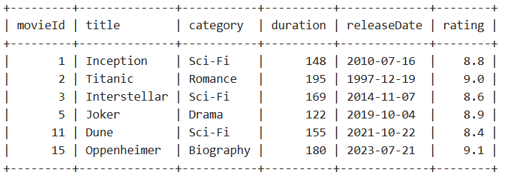

-- 3. Total bookings per theater with theater details
SELECT t.name AS theater_name, COUNT(b.bookingId) AS total_bookingsFROM Theater tJOIN Showtime s ON t.theaterId = s.theaterIdJOIN Booking b ON s.showId = b.showIdGROUP BY t.theaterId;
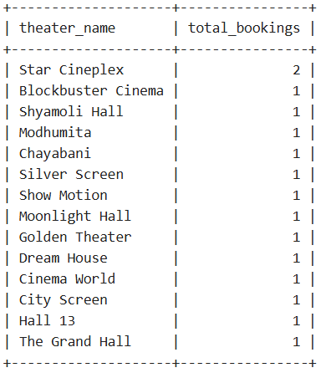

6.CEP Mapping
Our Movie Ticket Management System (MTMS) is a complex engineering problem because our code implements a complete relational database covering Movies, Customers, Theaters, Tickets, Showtimes, Bookings, and Payments.The structure of our code requires understanding of database design, relational dependencies, foreign keys, constraints, aggregate queries, subqueries, and data analytics.Since our code connects multiple real-world entities and operations through SQL, it satisfies the requirements of a complex engineering problem.

K’s Attribute | How this attribute is addressed in our code | CO | PO
K3 – Engineering Fundamentals | In our code, we use fundamental DBMS concepts like CREATE TABLE, primary keys, foreign keys, constraints, normalization, and SQL operations. Our code contains well-structured entities such as Movie, Customer, Ticket, Theater, Showtime, Booking, and Payment. | CO1, CO2 | PO1, PO2
K5 – Engineering Design | Our code demonstrates strong engineering design: all entities are linked logically (Movie → Showtime → Booking → Payment). The design decisions in our code ensure real-world movie ticketing workflow representation. | CO3, CO4 | PO3
K6 – Engineering Practice | Our code uses SQL operations such as INSERT, UPDATE, ALTER TABLE, JOIN, GROUP BY, HAVING, and Subqueries. This reflects real engineering practice by implementing and testing a functional DB system. | CO1, CO3, CO5 | PO2
P’s Attribute | How this attribute appears in our code | CO | PO
P1 – Depth of Knowledge Required | Designing the 7 major tables in our code requires deep knowledge of relational modeling, dependencies, and SQL schema design. Our code shows strong understanding of these fundamentals. | CO1, CO3 | PO1
P3 – Depth of Analysis Required | In our code, advanced SQL queries (subqueries, aggregates, joins, updates with CASE, etc.) require analytical ability to model real-world booking, payment, and scheduling logic. | CO3, CO4 | PO2
P7 – Interdependence | Our code shows interdependency between tables: Booking depends on Customer, Movie, and Showtime; Payment depends on Booking and Theater. These relationships demonstrate interconnected system design. | CO4, CO5 | PO3

A’s Attribute | How this is satisfied by our code | CO | PO
A2 – Problem Investigation | Our code includes queries that analyze customer behavior, movie categories, pricing, membership changes, booking count, and payment totals. This demonstrates investigation of real-world problems. | CO3, CO5 | PO2
A4 – Modern Tool Usage | Our code uses modern DBMS features: ALTER TABLE, CASE statements, aggregate functions, CROSS JOIN, and subqueries, representing contemporary database tool usage. | CO1, CO3 | PO5
A5 – Engineering Activities | Our code performs full engineering tasks: designing schema, inserting data, updating attributes, modifying structures, and generating analytical reports. This reflects complete engineering activity workflow. | CO4, CO5 | PO3

7. Conclusion
This Cinema Booking System project demonstrates a well-structured relational database design. It supports efficient management of movies, showtimes, theaters, customers, bookings, and payments. Through SQL queries, the system provides insights into customer behavior, movie popularity, and financial tracking. The database design emphasizes entity relationships, referential integrity, and real-world business logic implementation.

